 | International Journal of Arts, Humanities, Tourism and Cultural Studies  Journal Home Page: https://ijahtcs.com/  Vol. 1 Issue.1(Jan-June) (2026) | 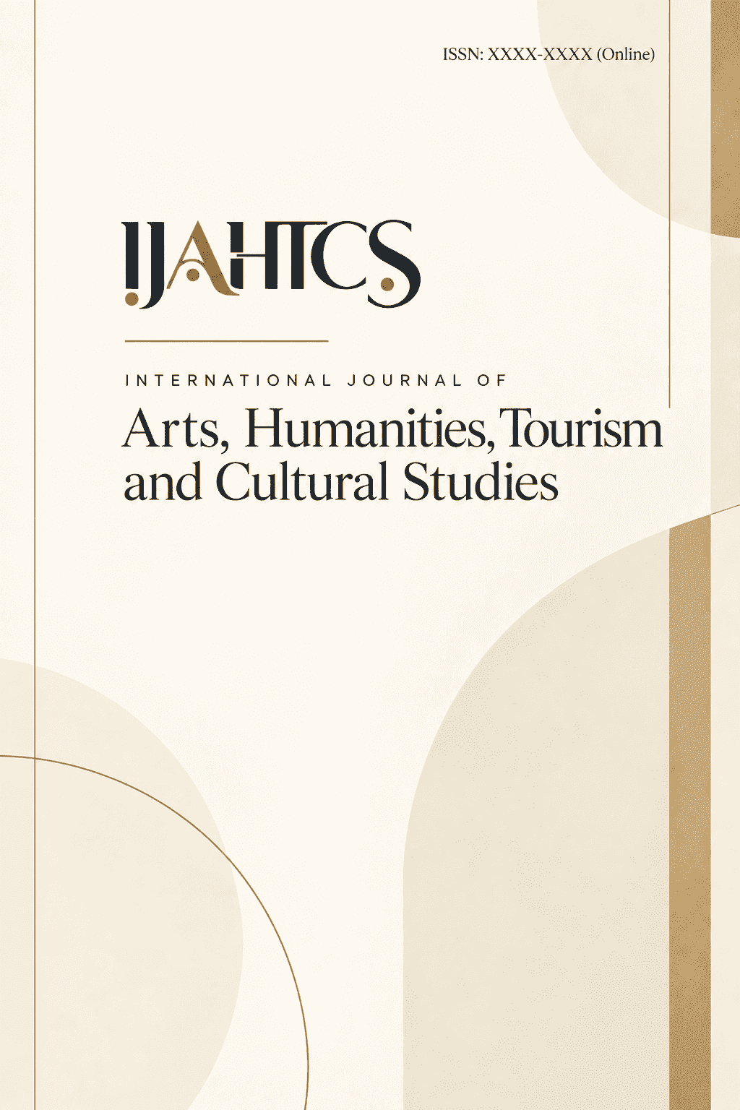
Research Paper Open Access

Superb Fairy-Wren Optimized Lightweight Convolutional Refinement Network for Analyzing Generational Teaching Differences and Efficacy In Malappuram, Kerala
Mr. Nikhil PP1, Dr. Rajamani A2

1Research Scholar, Department of Management Studies, Rathinavel Subramaniam College(RVS), Bharathiar University.
2Associate Professor, Department of Management Studies, Rathinavel Subramaniam College(RVS), Bharathiar University.

Abstract

This study investigated the influence of generational teaching differences on educational efficacy within the Malappuram District, Kerala. Recognizing the limitations of existing deep learning models in analyzing these nuanced variations within a specific regional context, a Superb Fairy-wren Optimized Lightweight Convolutional Refinement Network (SFOA-optimized LCRN) was developed. This network captured complex and non-linear relationships within educational data to provide a robust framework for predicting teaching effectiveness. Optimization via the SFOA ensured efficient parameter tuning and enhanced model interpretability. Here, the data encompassing teacher demographics, survey responses detailing teaching methodologies, and quantitative measures of performance underwent rigorous preprocessing. This process included Multivariate Imputation by Chained Equations (MICE) for missing value imputation, Tanh-Estimator for outlier management, categorical data encoding through ordinal and one-hot encoding, textual data processing utilizing Natural Language Processing (tokenization, stemming, stop word removal), and numerical data normalization. The preprocessed data was analyzed through the SFOA-optimized LCRN to enable the identification of generational patterns along with the prediction of teaching effectiveness. The SFOA-optimized LCRN demonstrated significant performance improvements over existing models. Specifically, accuracy reached 99.7%, precision 98.95%, recall 98.87%, F1-score 98.91%, and specificity 99.02%. Furthermore, the model achieved an execution time of 91ms to highlight its computational efficiency. Practical recommendations, including tailored training programs, mentorship initiatives, and collaborative teaching strategies, were generated to address identified generational variations. These strategies aimed to foster an inclusive and technologically adaptive learning environment. The SFOA-optimized LCRN effectively analyzed generational teaching differences to lead to improved educational strategy development within the specified regional context.

Keywords: Lightweight Convolutional Refinement Network, Superb Fairy-wren Optimization Algorithm, Generational Differences (Teachers), Teaching-Learning Process, Educational Outcomes.

Introduction
A significant generational shift shapes the contemporary higher education landscape in Malappuram, Kerala. Student demographics have transitioned from predominantly Millennial (born approximately 1981–1996) to Generation Z (born approximately 1997–2012), demanding a critical reassessment of pedagogical practices [1]. This shift demands effective engagement with a cohort defined by digital immersion and distinct learning preferences [2-3]. Consequently, a systematic examination of generational differences in teaching methodologies and efficacy emerges [4]. The analysis explores experiences, perceptions, knowledge, and concerns regarding generative artificial intelligence (GenAI) integration [5]. A comparative study between Gen Z students and Gen X (born approximately 1965–1980) and Millennial (Gen Y) educators elucidates differing perspectives on GenAI implementation [6-7]. Intentions and concerns surrounding GenAI adoption in higher education are examined for both student and teacher populations [8]. Existing literature highlights substantial variations in teaching preferences, learning styles, technology use, and communication methods across generations [9]. Understanding these nuances is essential for responsible and effective GenAI integration. Additionally, identifying support structures for Gen X and Gen Y educators navigating technological advancements remains crucial [10].

Literature Survey
This section provides a comprehensive review of recent advancements in analyzing generational differences in technology integration and their impact on teaching effectiveness in higher education. Some of the recent works are given below, In 2023, Chan, C.K.Y. and Lee, K.K., et.al [16] proposed AI Generation Gap by exploring generational perceptions of generative AI in higher education with a focus on Gen Z students versus Gen X/Y teachers (AI generation gap). Through a survey-based workflow, data was gathered regarding experiences with perceptions and intentions. Gen Z students demonstrated optimism regarding AI’s potential for efficiency with personalized learning. Teachers acknowledged benefits with concerns about overreliance and ethical implications as a distinct disadvantage noted in their feedback. By paralleling anticipated constraints of this approaches in discerning subtle data nuances, divergent adoption frequencies with anxieties across generations emerged.

Problem Statement and Motivation
The rapid generational shift in Malappuram's higher education transitioning from Millennial to Gen Z students, necessitates a critical reassessment of pedagogical practices particularly in integrating Generative AI (GenAI). This study addresses the challenge of engaging a digitally immersed Gen Z cohort while navigating generational disparities in technological proficiency and pedagogical philosophies between Gen X/Y educators and Gen Z students [16-21]. Motivated by the limitations of existing deep learning applications in modeling complex interrelationships among.

Table 1: Dataset Structure for Generational Teaching Analysis
Feature Category | Feature Description | Data Type
Demographic Information | Age Group (25 and below, 26-40 (Millennial), 41-55 (Generation X), 56 and above (Baby Boomer)) | Categorical
Demographic Information | Highest Level of Education (Bachelor's, Master's, Doctorate, Other) | Categorical
Demographic Information | Years of Teaching Experience (Less than 5, 5-10, 11-20,  More than 20) | Ordinal
Demographic Information | Current Teaching Level (Primary, Secondary, Higher Education) | Categorical
Teaching Methodologies and Learning Outcomes | Preferred Teaching Style (Lecture-based, Interactive, Technology-integrated, Other) | Categorical
Teaching Methodologies and Learning Outcomes | Comfort with Adapting to New Methods (Very comfortable to Very uncomfortable) | Ordinal
Teaching Methodologies and Learning Outcomes | Frequency of Digital Tool Integration (Always to Never) | Ordinal
Teaching Methodologies and Learning Outcomes | Perceived Impact of Generational Diversity on Student Outcomes (Positive, Negative, No significant impact, Not sure) | Categorical
Advantages and Challenges of Generational Diversity | Perceived Advantage (Varied teaching styles, Exchange of experience, Increased adaptability, Other) | Categorical
Advantages and Challenges of Generational Diversity | Experienced Challenges (Differences in teaching  philosophies, Resistance to technology, Communication barriers, Differences in classroom management, Other) | Categorical (Multiple selection)
Advantages and Challenges of Generational Diversity | Difficulty Collaborating (Yes, frequently to Never) | Ordinal

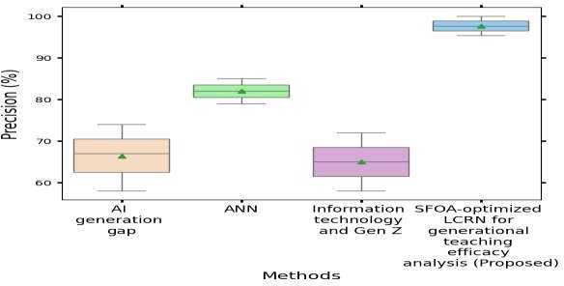

Figure 1: Sample

References
- Li, F., Wang, X., He, X., Cheng, L. and Wang, Y., 2022. The effectiveness of unplugged activities and programming exercises in computational thinking education: A Meta-analysis. Education and Information Technologies, 27(6), pp.7993-8013.
- Zhang, L.J., Fathi, J. and Naderi, M., 2023. A cross-lagged panel analysis of self-efficacy, teacher grit, teaching enjoyment, and work engagement among foreign language teachers. Journal of Multilingual and Multicultural Development, pp.1-19.
- Marrero Galva´n, J.J., Negrí´n Medina, M.A' ., Berna´rdez-Go´mez, A. and Portela Pruan˜ o, A., 2023. The impact of the first millennial teachers on education: Views held by different generations of teachers. Education and Information Technologies, 28(11), pp.14805-14826.
- Swim, J.K., Aviste, R., Lengieza, M.L. and Fasano, C.J., 2022. OK Boomer: A decade of generational differences in feelings about climate change. Global Environmental Change, 73, p.102479.
- Baham, C., Kalgotra, P., Nasirpouri Shadbad, F. and Sharda, R., 2023. Generational differences in handling technology interruptions: A qualitative study. European Journal of Information Systems, 32(5), pp.858-878.

